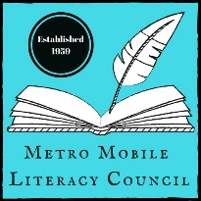

Parents,
I would love for our class to participate in this year’s Young Authors’ Conference. It is a great way for students to be recognized for the amazing work they do, and to be published in the annual Young Authors’ Anthology. Students may choose to submit a writing we are already working on in class, or they may decide to submit something different that they are working on at home. The registration form is attached, and your signature will be needed before I can submit any of their writings. Please take a moment to look over it. The conference is hosted by the Metro Mobile Literacy Council. For more information about this event and other literacy related topics, please visit their website: metromobilelit.weebly.com.
Thank you for all that you do to support your child and their literacy development.
Sincerely,

Parents,
I would love for our class to participate in this year’s Young Authors’ Conference. It is a great way for students to be recognized for the amazing work they do, and to be published in the annual Young Authors’ Anthology. Students may choose to submit a writing we are already working on in class, or they may decide to submit something different that they are working on at home. The registration form is attached, and your signature will be needed before I can submit any of their writings. Please take a moment to look over it. The conference is hosted by the Metro Mobile Literacy Council. For more information about this event and other literacy related topics, please visit their website: metromobilelit.weebly.com.
Thank you for all that you do to support your child and their literacy development.
Sincerely,

